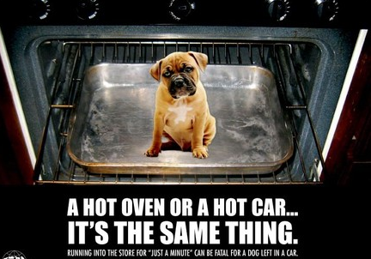
Left in the car
Around the world, young children and pets are often left in cars while their parents or carers quickly leave them to do odd jobs unaware of the degree to which the child or pet registers the internal temperature increase. In December of 2012, SBS news reported that a baby died in the Victorian regional city of Bendigo after being left inside a car. Reports of animals being found in states of distress due to being locked in cars are also regular news occurrences. .
- Why could this be happening? Surely the internal temperature of the car is similar to the outside.
_____________________________________________________________________________________
_____________________________________________________________________________________
____________________________________________________________________________________

- In small groups find the surface area of the ‘child’ and of one your group members
Do you think that a child is going to have a smaller or larger surface area to body mass ratio than an adult? Why/why not?
__________________________________________________________________________________
__________________________________________________________________________________
__________________________________________________________________________________

Part 1: Calculate the surface area of the child doll and then calculate the surface area of one of your group members. Don’t forget to show your workings out. Below are some formulas to help you complete the task..
Shape | Formulas for Area (A) and Circumference (C)
Triangle  h h  b b | A = ½ ×base× height
Square or rectangle  l l  w w | A = length× width
Trapezoid  b  h  b | A = ½ (sum of bases) ×height
Parallelogram  h  b | A= base × height
Circle  r  rrrrrr | A = π × r ²

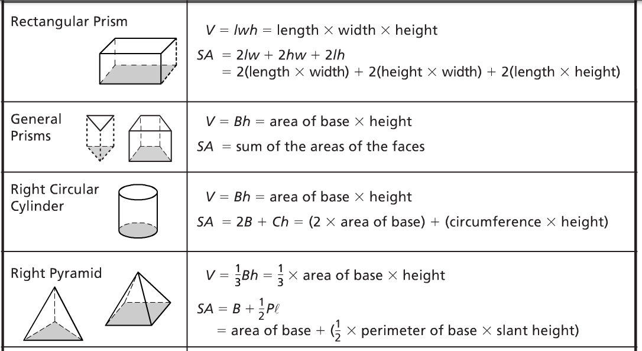
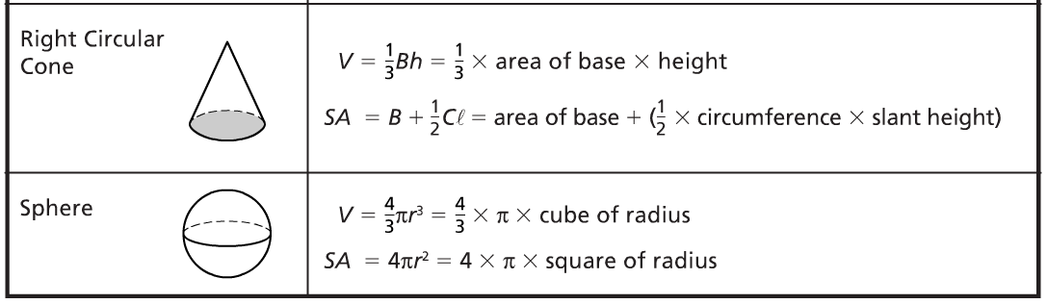

Extension Activities
Part 2: Find the surface area to body mass ratio of the child doll as well as your group member
You will need to know the surface area and an estimate of the mass of the group member you have measured and the child doll. The greater the surface area to body mass ratio the more heat that is absorbed
- The average body mass of 3 month old, a similar size to your ‘child’, is 5.8kg
- For your group member make an estimation of their weight using the chart.
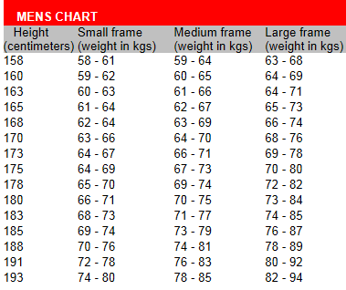
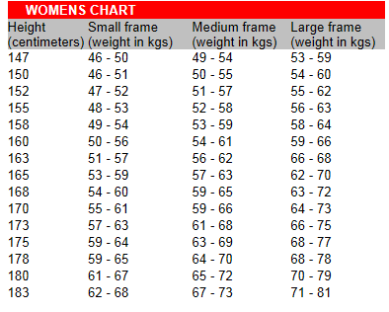http://www.alfitness.com.au/article/aID/120/cid/3/Find-out-your-ideal-weight-based-on-your-height
Check your answer using the Du Bois’ formula
S=71.84W^{0.425} L^{0.725}
S= surface area in cm2
W = body weight in kg
L = body length in cm

Part 3: What about dogs? Can I leave my Jack Russel in the car?
Find the surface area to mass ratio for a small dog. Is it different to a child?
(25-35cm) (6-8kg)

Part 4: Ibrahim Almanjahie from the University of Western Australia (2008) found that on a typical summer’s day, the temperature in a parked car can rise to more than 20ºC higher than the temperatures outside the car.
Table 1: Rise in temperature
Time in car | 10 minutes | 20 minutes | 30 minutes | 60 minutes
Temperature rise windows shut | 10.6 ºC | 16.1 ºC | 18.3 ºC | 24 ºC
Temperature rise windows open | 9.4 ºC | 11.7 ºC | 13.3 ºC | 21.1 ºC

- Draw a graph representing this information
- Draw two lines of best fit

Figure 1
- Using your lines find out the temperature rise after 40 minutes
- With the windows open?
- With the windows closed?

- How long does it take to rise 20 ºC
- With the windows open?
- With the windows closed?
- What else do you think might affect the rate taken for the car to heat up?

_________________________________________________________________________________

________________________________________________________________________________
Table 2: Temperatures in Hobart
Month | Hobart minimum average temperature (ºC) | Hobart maximum average temperature (ºC) | Hobart highest recorded temperature (ºC)
January | 11 | 22 | 40.8
February | 12 | 22 | 40.1
March | 11 | 21 | 37.3
April | 9 | 18 | 30.6
May | 6 | 15 | 25.7
June | 5 | 13 | 20.6
July | 4 | 12 | 22.1
August | 5 | 13 | 24.5
September | 6 | 15 | 31
October | 7 | 17 | 34.6
November | 9 | 19 | 36.8
December | 11 | 20 | 40.6

If the internal temperature of the car reaches above 40 ºC negative health effects will occur for the child or pet.
Using Table 1 and the Maximum average temperature in Table 2, calculate which months and how quickly the temperature will take to rise above 40 ºC. Record how fast it takes to reach the over 40 ºC assuming the windows are shut ?

Month | How long does it take to get over 40 ºC
January
February
March
April
May
June
July
August
September
October
November
December

Part 5: The average 12 month old child is 10.3 kg, the average adult male is 85kg and average female is 70kg
A 12 month old child loses 1 to 2 mL/kg per hour through perspiration
Adults lose 10 to 20mL/kg per hour
How long does it take a child to lose as much sweat as an adult? Figure it out mathematically. You can use any method.

Part 6
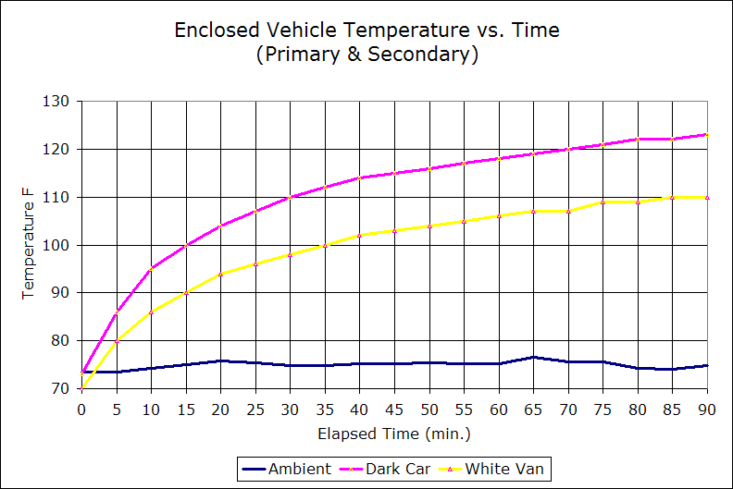
Figure 1 sourced from http://books.google.com.au/books?id=PCU0RwDI6c4C&pg=PA40&lpg=PA40&dq=body+size+and+heat+loss+people&source=bl&ots=syZL-iK7Xi&sig=ouwOvIl-BcuiN2zbQWCylmpgbZg&hl=en&sa=X&ei=V0NzUbioI-SRiQft4oDwBg&ved=0CEoQ6AEwAzgK#v=onepage&q=body%20size%20and%20heat%20loss%20people&f=false

- Using Figure 1 above, what was the difference in temperature between the dark car and the white at
- 30 minutes?

- 60 minutes?

- 90 minutes?

- Using the Fahrenheit to Celcius online converter http://www.metric-conversions.org/temperature/fahrenheit-to-celsius.htm calculate the difference in temperature in degrees Celcius
- 30 minutes

- 60 minutes

- 90 minutes

- Does the size of the car make a difference? if I have a larger car, is it safe to assume that I can risk leaving my child or pet in there for longer
- Design a way that you could test this
- If I leave a bowl of water in with them does it make a difference?

